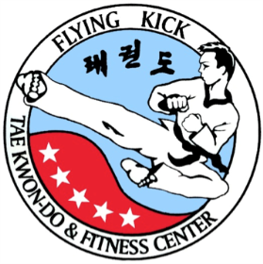

Flying Kick Fitness™ is Proud
to Present:
Kick-A-Thon 2015 - Sunday, November 22

On Sunday, November 22, Flying Kick Fitness Inc. is pleased to announce a special Kick-A-Thon for one of our own taekwondo family. In the past we have hosted Kick-A-Thons for worthy causes, such as the tsunami, the earthquake in Haiti, and St. Jude’s Hospital for Children and in memory of Derek Park. These events gave us the opportunity to have fun, train hard, and raise money for important charities. The Kick-A-Thon is for Dr. Ernest Brown.

Dr. Brown's passion and dedication to caring for those in need set a unique and needed example for the medical community. Dr. Brown is a native Washingtonian and family physician who has been providing charity house calls to frail elderly, veterans, and many others in need for more than 8 years throughout the Washington DC Metropolitan area. Funds will go to support home visits, medications, and more. Dr. Brown and his son have been students at Flying Kick and have been part of the Flying Kick family for many years. For the past several years he has donated his time as the Flying Kick Summer Camp medical director and physician on call. Additionally he has cared for several students who were in need of medical assistance. His goal is to get other doctors to join him so they can get back to doing what they do best: caring. To learn more about Dr. Brown, visit his GoFundMe page at http://bit.ly/1F0i0uP.

In each class we will do at least 500 kicks. The idea is to get the support of family and friends to raise money for each kick – similar to a walk for cancer, etc. Each student participating in the kick-a-thon will need to talk to family and supporters to raise money – usually something like $.01 or $.05/kick. On the day of the Kick-a-Thon (November 22), Master A will lead each class in kicks and record the number performed. He will sign the students’ registration forms (attached) to attest to the number completed by the student, who will then bring the form to the sponsors and collect the check(s). The checks should be made payable to Dr. Ernest Brown Housecalls. ALL CHECKS MUST BE IN THE STUDIO OFFICE BY DECEMBER 6. Registration information is available in the studio.

Please note that you do not have to be signed up for the Kick-A-Thon to take part in classes on November 22 – all students are welcome. Classes will be dedicated to kicking – part of our normal curriculum! But we would encourage you to join us in this fun way to combine training with a show of support to our Flying Kick Taekwondo Family.

